Introduction :

- A time server is a server that reads the actual time from a clock and distributes this information to its clients using a computer network. The time server may be a local network time server or an internet time server.

Program :

server.py

import datetime
import datetime
#creating a tcp socket
server_socket = socket.socket(socket.AF_INET,socket.SOCK_STREAM)
#binding the socket to localhost with port no 9060
server_socket.bind((socket.gethostname(),9060))
server_socket.listen(10)
while True:
(client_socket,address) = server_socket.accept()
print("client details : ",client_socket.getsockname())
#sending the current time to client
client_socket.send(str(datetime.datetime.now()).encode())

client.py

import socket
client_socket = socket.socket(socket.AF_INET,socket.SOCK_STREAM)
#connect to localhost with port 9060
client_socket.connect((socket.gethostname(),9060))
#print the message sent by the server
print(client_socket.recv(1024).decode())

output :

server

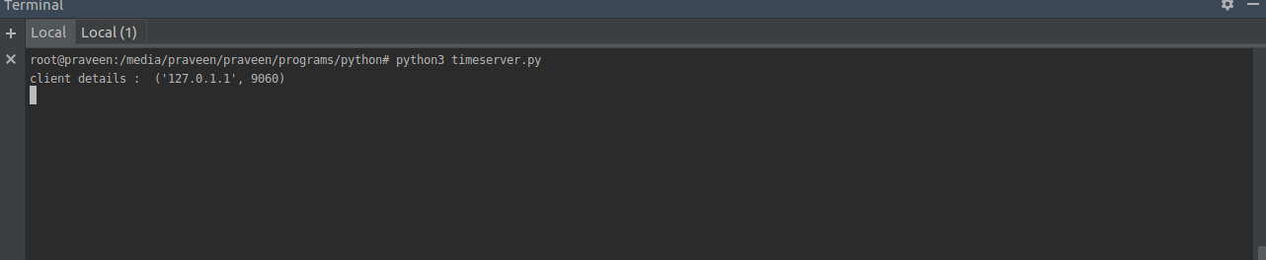

client

